Troubleshooting Application Failures

Hands On – Troubleshoot a failing Application

In this lab we will deploy a pod that wont run. For the purposes of this training I will point out the issue and then we will resolve the root cause of failure from cloud shell.
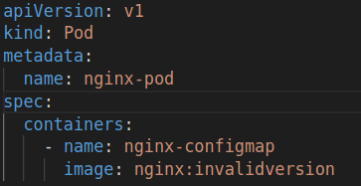

I. Deploy the faulty manifest
Create the manifest above, apply your deployment to the cluster, and verify.

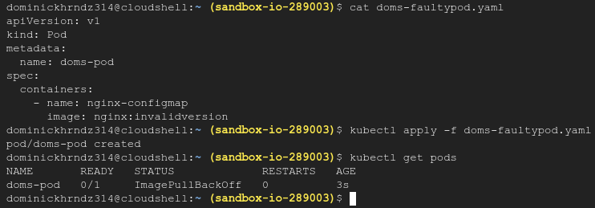
We see under Status an message saying ImagePullBackoff.

II. Explore the reason for failure
First let’s pull the logs for the pod.
We see that the container in my pod is waiting to apply an image but can’t do so. Now let’s look at the description of the pod. We see that the image is invalid.
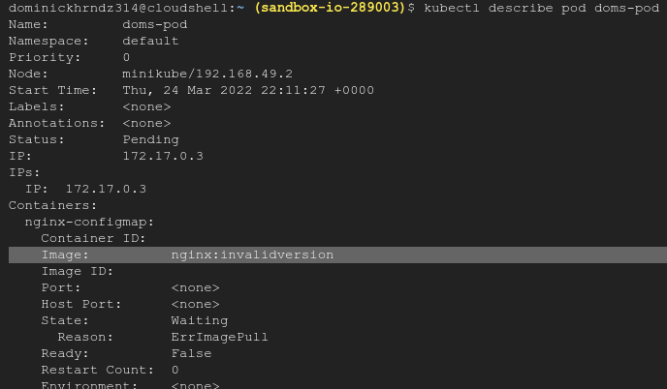
If look further down we also see in the events that a warning was triggered 20 seconds ago from the kublet. We have failed to pill an image because the description is unknown as well as the manifest.
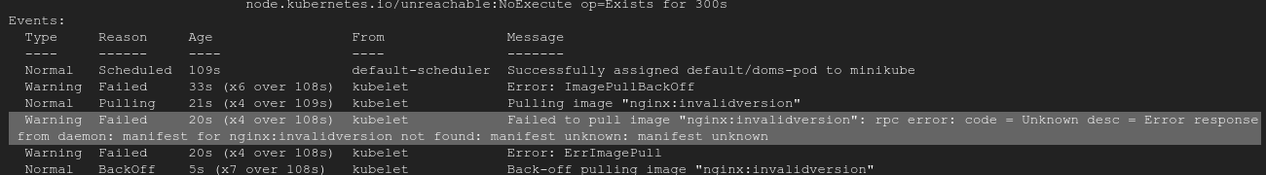
III. Resolve the issue
To resolve the issue we need to provide the correct version information for our pod. Let’s edit the manifest to reflect version 1.14.2 as listed here:
https://kubernetes.io/docs/concepts/workloads/controllers/deployment/

Since we’ve changed the version and applied the new manifest we can see that the pod is back in working order.

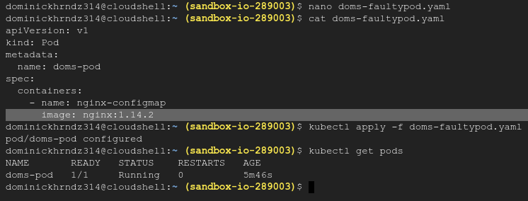
If your pod is now running and ready you have completed this training.

